This chapter includes minor edits to the EIR. These modifications resulted from responses to comments received during the Draft EIR public review period.
Revisions herein do not result in new significant environmental impacts, do not constitute significant new information, and do not alter the conclusions of the environmental analysis that would warrant recirculation of the Draft EIR pursuant to State CEQA Guidelines Section 15088.5. Changes are provided in revision marks with underline for new text and strike out for deleted text.

3.1 Revisions to the Draft EIR

Global Changes
The name of the Project analyzed in the EIR is the “Cotati General Plan.” Which replaces all references to the “2013 Cotati General Plan.”

Executive Summary
No changes were made to the Executive Summary of the Draft EIR (DEIR).

1.0 Introduction
No changes were made to Chapter 1.0 of the DEIR.

2.0 Project Description
No changes were made to Chapter 2.0 of the DEIR

3.1 Aesthetics and Visual Resources
No changes were made to Section 3.1 of the DEIR.

3.2 Air Quality
The following edits were made to page 3.2-4 of the DEIR:
Respirable particulate matter (PM₁₀) consists of small particles, less than 10 microns in diameter, of dust, smoke, or droplets of liquid which penetrate the human respiratory system and cause irritation by themselves, or in combination with other gases. Particulate matter in Sonoma Colusa County is caused primarily by dust from grading and excavation activities, from agricultural uses (as created by soil preparation activities, fertilizer and pesticide spraying, weed burning and animal husbandry), and from motor vehicles, particularly diesel-powered vehicles. PM₁₀ causes a greater health risk than larger particles, since these fine particles can more easily penetrate the defenses of the human respiratory system.

3.3 Biological and Natural Resources
This section was revised to include new and revised information to the EIR based on comments noted by Jenny Blaker, a citizen in Cotati. The revisions include corrections and updates of the existing information which is incorporated into the EIR. The changes to the text in the EIR occur in Section 3.3 Biological Resources in Table 3.3-3 (Special Status Animals Present or Potentially Present in Cotati) on Page 3.3-10. There were two figures that were updated based on new CNDDB queries. The updated figures include Figure 3.3-2 (page 3.3-47) and Figure 3.3-3 (3.3-49).

Table 3.3-3: Special Status Animals Present or Potentially Present in Cotati
Species | Status | Habitat

Amphibians
Ambystoma californiense California tiger salamander | FE (Sonoma County DPS)/CT  FT/CT | Need underground refuges, especially ground squirrel burrows and vernal pools or other seasonal water sources for breeding.

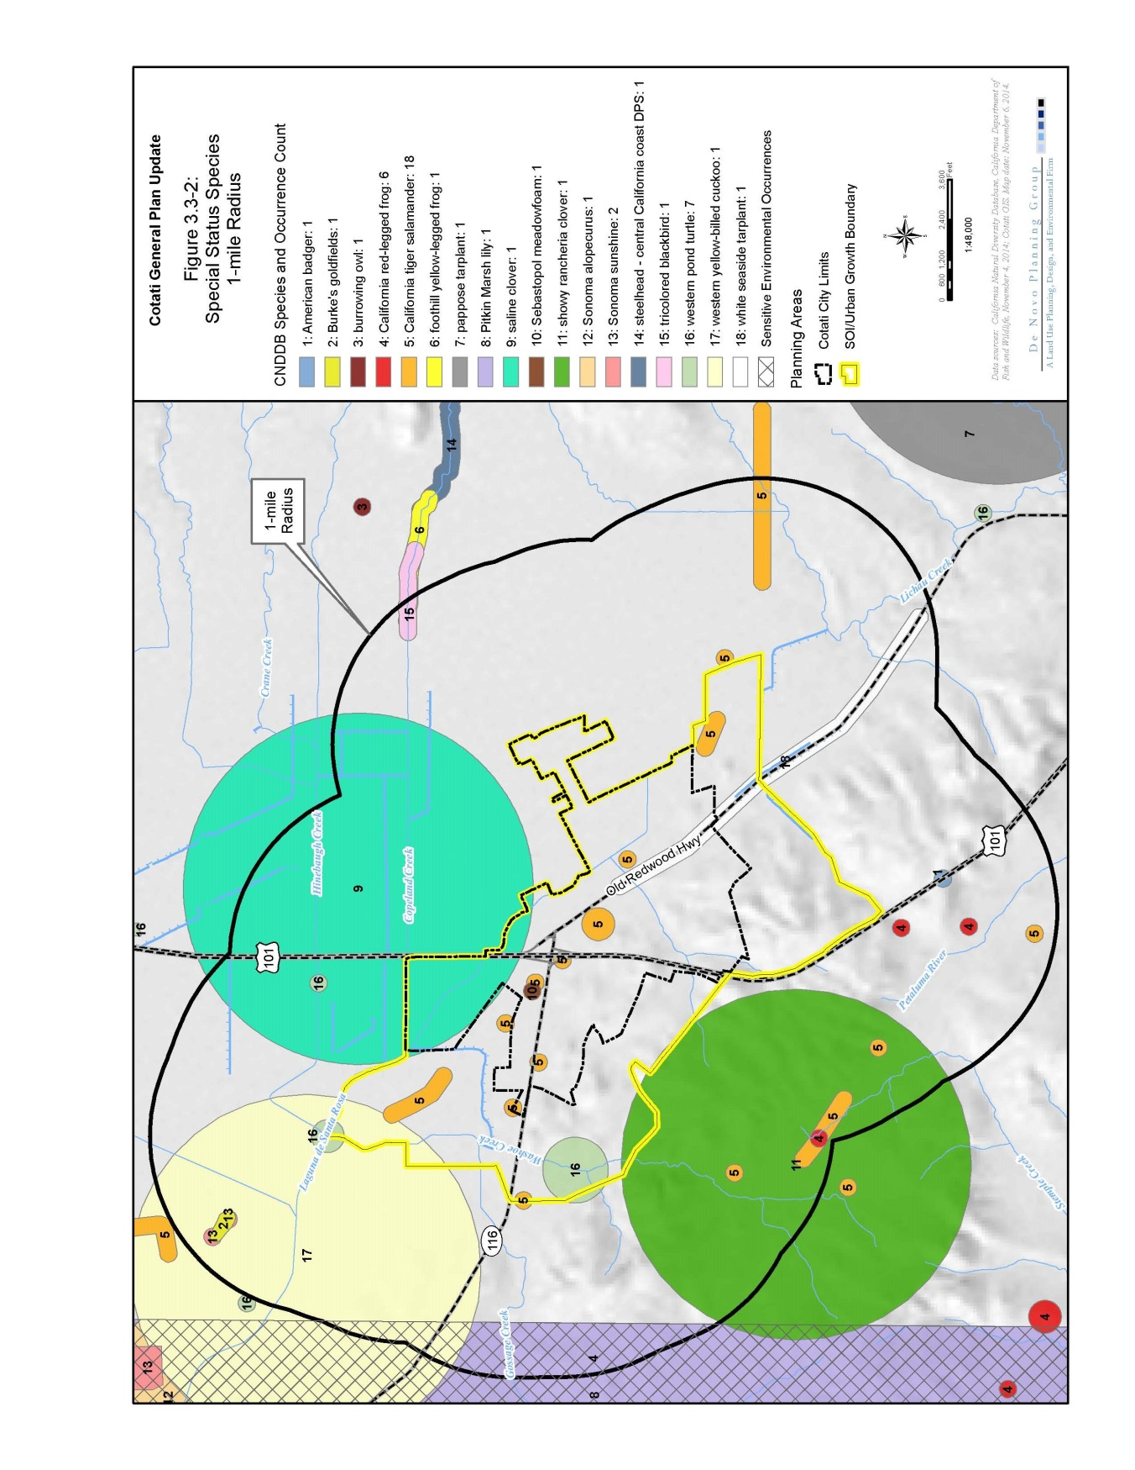
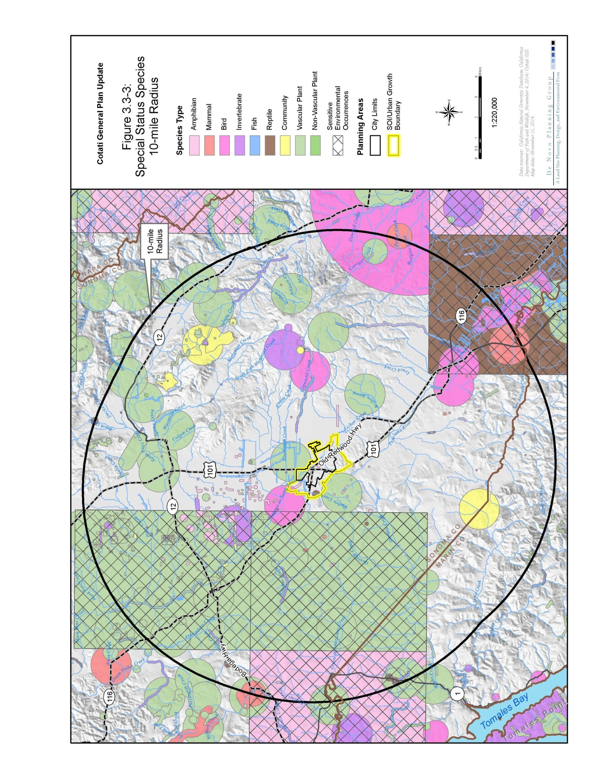
3.4 Cultural Resources
No changes were made to Section 3.4 of the DEIR.

3.5 Geology and Soils
No changes were made to Section 3.5 of the DEIR.

3.6 Greenhouse Gases and Climate Change
No changes were made to Section 3.6 of the DEIR.

3.7 Hazards
No changes were made to Section 3.7 of the DEIR.

3.8 Hydrology and Water Quality
No changes were made to Section 3.8 of the DEIR.

3.9 Land Use, Agriculture, and Population
No changes were made to Section 3.9 of the DEIR.

3.10 Noise
No changes were made to Section 3.10 of the DEIR.

3.11 Public Services and Recreation
No changes were made to Section 3.11 of the DEIR.

3.12 Transportation and Circulation
The following changes were made to pages 3.12-6 and 3.12-7 of the DEIR:

Golden Gate Transit
Golden Gate Transit Routes 74, 80, and 101 serve Cotati with stops located at either the Hub, or the St. Josephs Park and Ride, and at Water Road/West Sierra Ave. Commute service to and from San Francisco is provided weekdays in the morning and evening hours at approximately one hour intervals between 4:00 and 9:00 AM and 6:00 and 10:00 PM, with stops in various communities along the US 101 corridor including Santa Rosa to the north and various cities in Marin County to the south. Weekend service is provided hourly between approximately 4:00 AM and 10:00 PM. No capacity issues were identified on existing service routes.

This section was revised to include a correction to Figure 3.12-9 on page 3.12-77 of the Draft EIR. A comment letter received from Caltrans noted a typo regarding traffic volumes on Intersection 12 on Figure 3.12-9. The original figure incorrectly showed 216 southbound AM approach trips, rather than correctly showing 21 trips. This typo has been corrected. The revised and corrected figure is provided below.
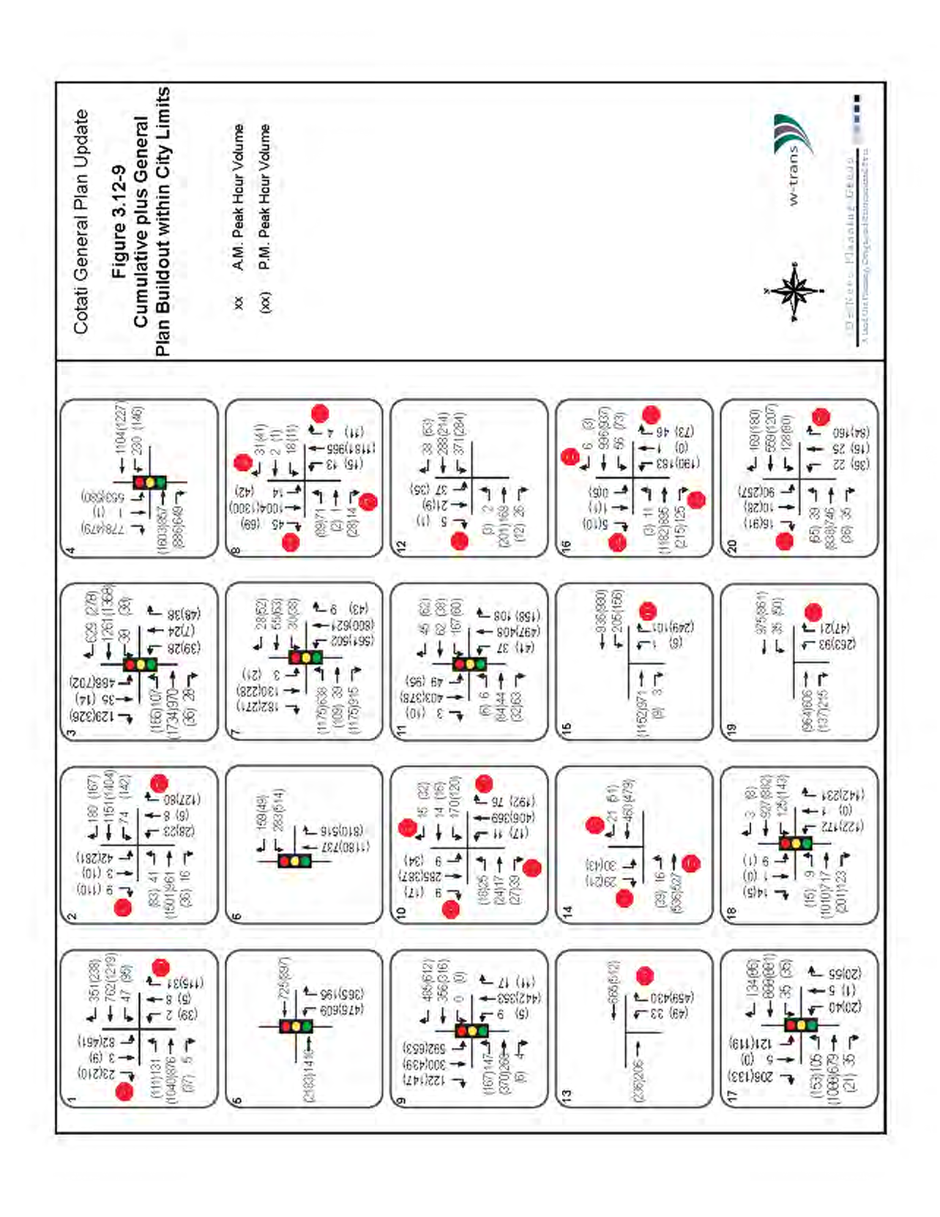

3.13 Utilities
The following changes are made to page 3.13-3 of the DEIR:
The water rights by which the City of Cotati obtains Russian River water are held by the SCWA and permitted by the California State Water Resources Control Board (SWRCB). The SCWA has the right to divert up to a total of 75,000 AFY for its water contractors and customers. The SCWA has filed an application for various petitions pertinent to the City’s water supply with the SWRCB, which would include water rights diversions from the Russian River to 101,000 AFY. Water supply projections in the 2010 SCWA UWMP includes the assumption that surface water supplies from the Russian River will increase to above 75,000 AFY by 2027 to 80,000 AFY in 2035.

4.0 Other CEQA-Required Topics
No changes were made to Chapter 4.0 of the DEIR.

5.0 Alternatives
No changes were made to Chapter 5.0 of the DEIR.

6.0 Report Preparers
No changes were made to Chapter 6.0 of the DEIR.

